# JavaScript Comprehensive Assignment

## INSTRUCTIONS:

* **Purpose of assignment**:
  + This assignment is intended to teach you how to utilize online resources to solve any given problem **without depending on others.** Though you can ask questions and seek support from staff, please try to implement this assignment on your own.
* **What to implement:**
  + Please code this wireframe using standards compliant HTML 4, HTML5, CSS2, CSS3, JavaScript and JQUERY.
  + Please refer to w3schools.com for HTML5 tags and CSS3 properties.
  + **BONUS POINT:** Please implement HTML5 Geo location for this application. Also, implement CSS3 Box-Shadow. (Search online)
  + A div based table-less format should be used for layout.
  + Students in JQUERY batch should use JQUERY1.8 version. Students in JavaScript batch should write code in pure JavaScript without using any libraries.
* **Coding Standards (MANDATORY TO FOLLOW UP):**
  + All code should validate against W3C standards (no errors, no warnings) and be cross-browser compatible among all 'grade A' browsers.
  + A folder structure has been created for you. Please include all of your CSS in an external style sheet in styles folder. Image assets needed to complete the exercise are located in the 'images' folder and specified in the annotations.
  + **IMPORTANT:** Please include comments in your code briefly explaining about the code that you wrote.
  + **Please make sure to use good colour schemes in your assignment. Come up with a creative “look and feel”. (See** [**this**](http://www.w3resource.com/twitter-bootstrap/tutorial.php) **if you are interested)**

## Page 1 (HOME PAGE)

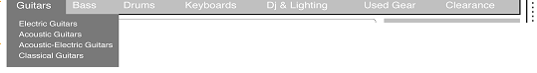

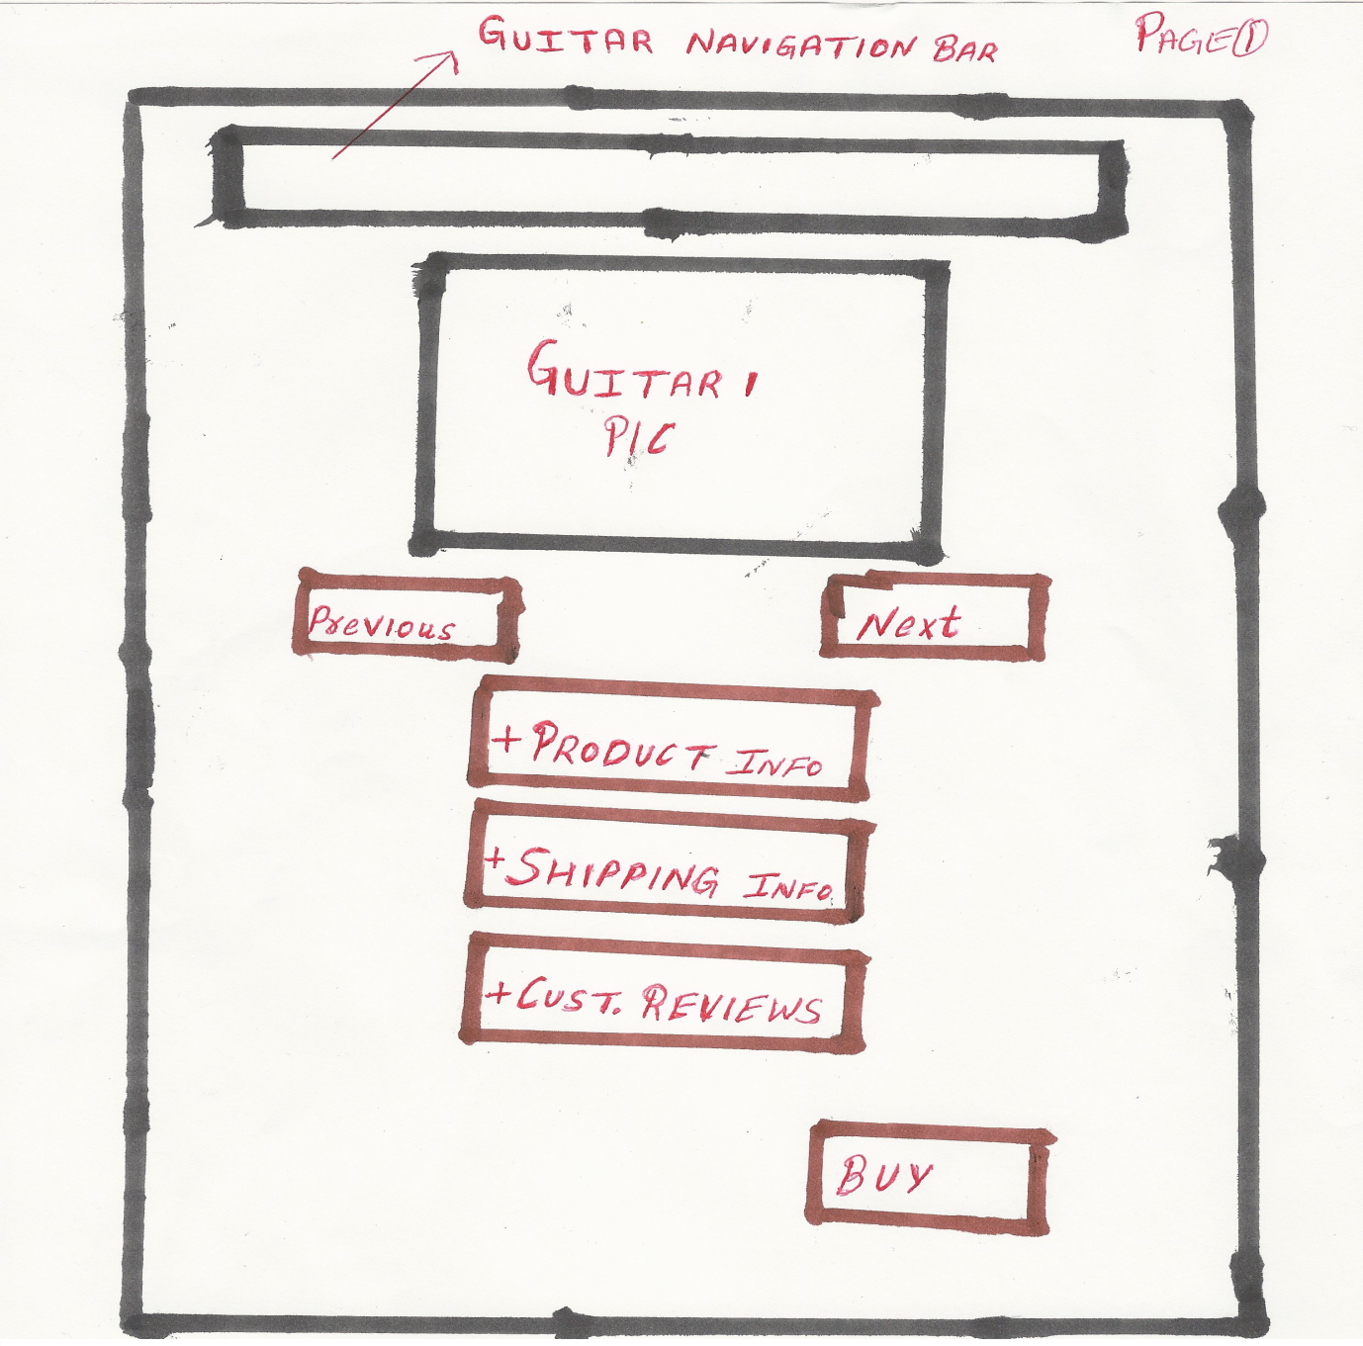

* This page 1 should have Navigation Bar
* This page should have Image Gallery of the Guitar with respective Divs for “Product Info”, “Shipping Details” and “Customer Reviews”.
* These divs should have Expand/Collapse functionality. The data inside each these div should change when the user clicks “Next” or “Previous” button on the gallery.
* When Clicked on BUY, the user should be taken to Page 2.

## PAGE 2: Order Purchase Page

* Selected Guitar Image (From page 1). Beside the image, guitar description
* Purchase Form should include atleast 8 fields (typical Credit Card purchase form) with a button “Review Order”
* Once Review order is clicked, the form should be hidden and a “Preview Order Info” section should be shown which will contain the information that user entered in the Purchase Form.
* This “Preview Order Info” should have two CTAs (Call to Action) buttons:
  + “Edit” button. When clicked, the “Preview Order Info” should be hidden and the Purchase Form should be visible for the user to edit.
  + “Buy” Button. When clicked, the user should be taken to confirmation page (Page 3).

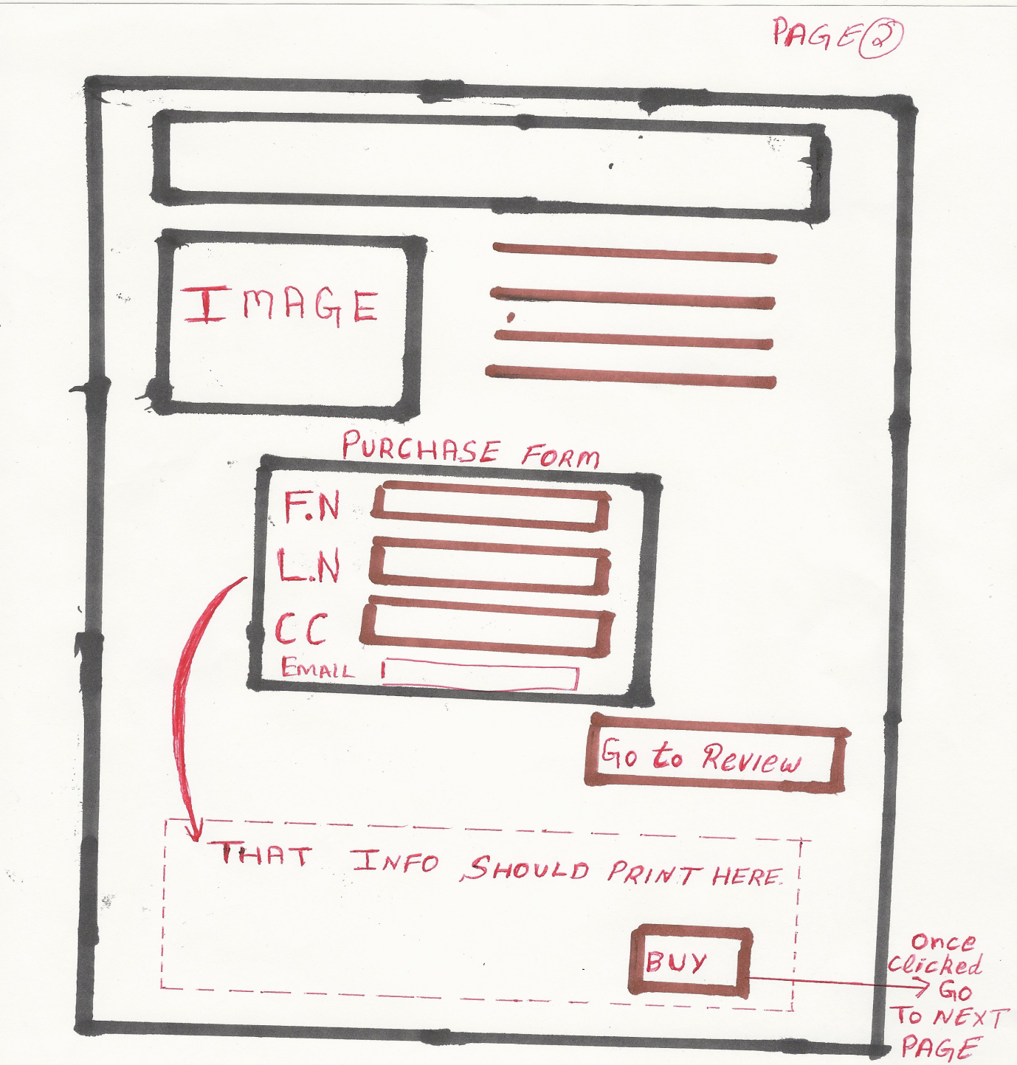

## Page 3: Confirmation Page

* Display the Image of the guitar that was purchased.
* Description of the image and Order Details (Order #, Shipping Details, Final Price,etc)
* A CTA(Call to Action) button to Home Page.

